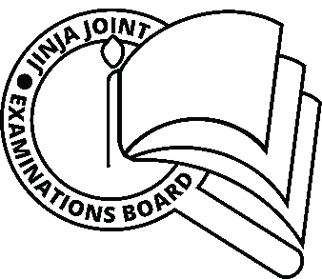**JINJA JOINT EXAMINATIONS BOARD**

**MOCK EXAMINATIONS 2022**

**FOOD & NUTRITION P640/2 2022**

**MARING GUIDE**

**1 a. Explaining the working principle of a septic tank**

* Made of two tanks /pits below the ground.
* The sewage drains from the house into the first tank where bacterial action slowly breaks solid sewage down into gas and liquid scum and sludge.
* Sludge gradually sinks to the bottom of the tank.
* Sludge takes a considerable time before it’s removed depending on the load of sewage therefore time it will take to get full.
* A filled tank is detected when bad odour begins to escape through the fresh air inlet and vent pipe into the air
* The liquid part of the sewage passes to the second tank/soak pit where further bacterial action slowly makes it harmless.

The soak pit is filled with stones so as to allow the liquid to seep through to the surrounding soil.

* The gas produced by the action of bacteria is poisonous and explosive .
* The septic tank has an opening known as FAI (Fresh Air Inlet) to dispose of this gas.

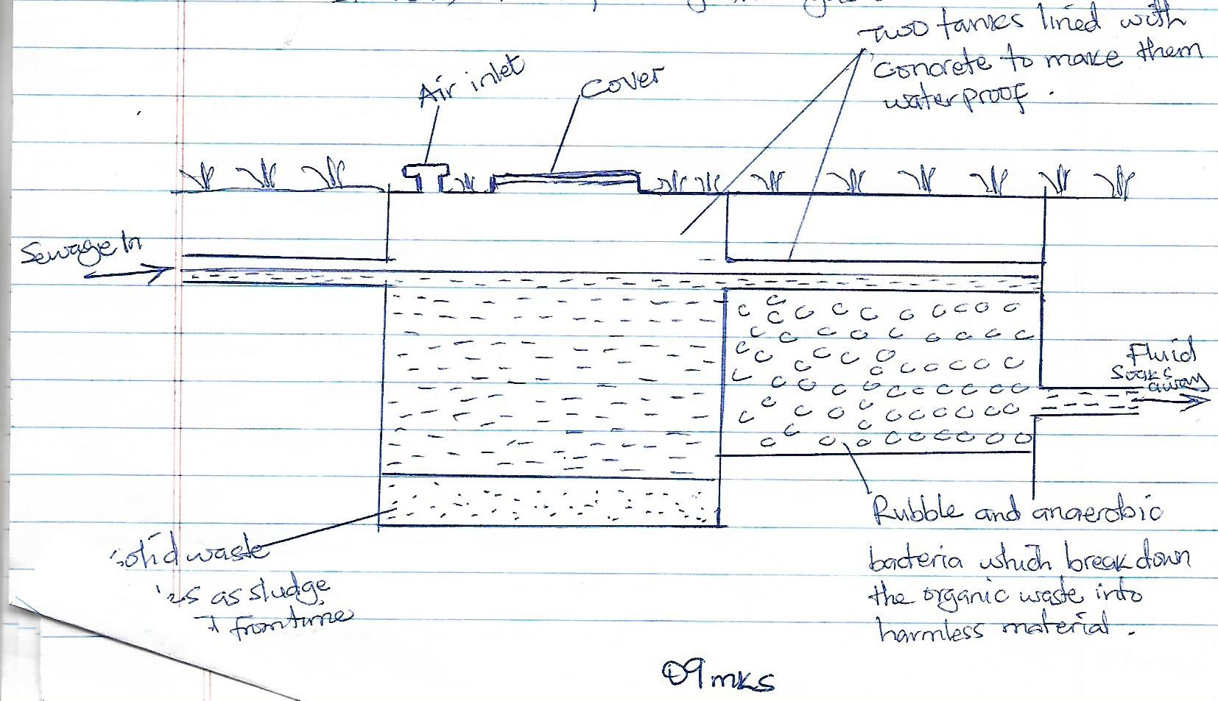

09mks

**b. How to maintain drains that are constructed for disposal of waste water in a home.**

- Avoid use of solid materials which will cause blockage of the system.

- Inspect through the manhole when water flow is slow.

- Keep the drains properly covered to avoid flow of waste water on the compound

- Rinse kitchen drains with hot water.

- Toss some baking soda into the drain.

- Install strainers in kitchen sinks.

- Let the professional (plumbers) do the hard work.

04mks

**C (i) Characteristics of a good drain trap**

* Should be easy to unblock/cleaned.
* It should provide sufficient water seal.
* It should be easily fixable with the drain or pipes.
* It’s internal and external surface should be smooth
* It should provide self – cleaning property
* It should be simple in construction.

**(ii) How piped water can get contaminated in the home.**

* When fresh water pipes are running close to the sewerage pipes.
* When piped water is collected in dirty containers.
* When the pipe is open especially during rainy season, the water gets contaminated as it comes in contact with muddy run off.

**2 a. Explaining the uses of the following cleaning agents**

1. **Salt**.

* Used as an abrasive with citric remove rust stains on iron equipment.
* Used for disinfection when added to water clean clothes of sick people e.g Handkerchiefs are raised in salty if one had flu (sainting agent).
* For removing blood stains.
* For fixing colours in coloured fabrics which loose colour.
* For preservation of food
* Used as an anti –septic in dilute solutions.

03mks

1. **Ammonium hydroxide**

* Softening hard water
* Used for cleaning upholstered surfaces
* Stain remover (acidic stain)
* Neutralizes acids during laundry. 03mks.

1. **Paraffin**

* Remove sap stains e.g banana stain i.e used for dissolving grease.
* For cleaning dark painted surfaces. 03mks

**(iV) Acetic Acid**

* To descale and remove calcium salts from closets, pans and cookers.
* Removes over blueing in laundry
* Used to remove ink and iron rust stains.
* It forms an essential constituent of paste for polishing metal.

**b Describing the properties of glass which make it a functional material in the home.**

* It is transparent
* It is non- porous
* It is a non conductor of heat and therefore it retains heat
* Glass breaks if suddenly subjected to extremes of temperature or sharp impact.
* When used for construction purposes, it acts as a good fire proof.
* It does not absorb odours, and its impervious to air, water and grease.
* Glass does not loose its hardness or brilliance through exposure to moisture.

08mks

**c. Giving the characteristics of plastic that make it popular to household and industrial use.**

- Good electrical insulators

- Do not corrode or decay

-They have good resistance to most chemicals.

- Water proof and generally grease proof

- Some are very hard and withstand scratching.

- Relatively cheap to produce in large quantities.

- Can be molded into shapes and made into sheets and films.

- Most expand with heat and eventually melt.

**3. a With the aid of diagrams, describe the following appliance of convection in home.**

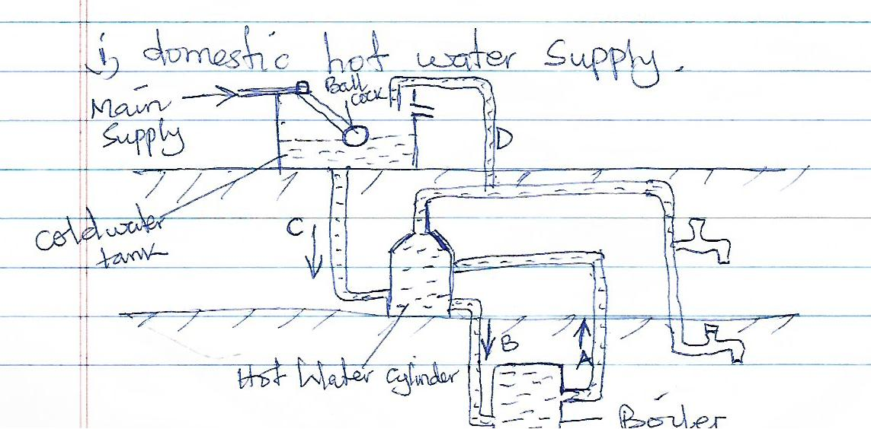

* A convection current of hot water from the top of the boiler reses up pipe A to the top of the hot water cylinder and cold water flows down pipe B from the bottom of the cylinder to the bottom of the boiler.
* Hot water is drawn off from the top of the cold water tank which enters the bottom of the cylinder by pipe C .
* Water is supplied from the mains to the cold water tank through a ball- cock.
* The expansion of pipe D allows the escape of dissolved air which comes out of the water when the water is heated, and steam of the water boils.

If an outlet is not provided air can cause air blocks in the pipes and steam may cause an explosion.

08 mks

**(ii) Domestic room ventilation**

* Ventilation of rooms using a heating appliance depends on the formation of convection currents.
* The warm state air rises and flows out through the lower part of the window or ventilator, the latter may incorporate a small pre- heater to overcome chilling of the room in cold seasons. 06mks

**b. Explaining the importance of good ventilation in the kitchen.**

- To remove stale, impure air which is damaging to health.

- To remove unpleasant odours which develop when people are crowded.

-To introduce fresh air such a way that it brings about convection currents.

- To ensure that the air is neither too dry nor too humid.

- To prevent or reduce condensation.

05mks

**c. Stating the factors that determine the choice of domestic fuel.**

- Cost price – should be cheap

- Safety in use – should be safe to store and transport.

- Amount of heat energy released.

- Pollution/ cleanness

- Availability in large quantities

- Ease when using by all groups in the family

- Maintenance- costs of repair, care.

06mks

**4. a Explaining how you would purify drinking water at home.**

**BOILING**

* Water that has impurities is first filtered
* Water is boiled for 5 – 10 minutes and poured into clean containers to allow it to cool and mix it with oxygen.
* It’s then covered and kept for use.

**Chemical purification using chlorine**

* Water with impurities is first filtered
* Add drops of chlorine to 10-20 litres in a clean pot
* Leave for 30 mins and the water is now safe for use and you can cover it.

**b. (i) Outline the process of making soap by Boiling**

- A weak solution of caustic soda is first added to melted fat in the pan and the mixture is boiled.

- This causes some fat to be saponified

- The presence of soap formed emulsifies the rest of the fat making it more able to mix with caustic soda which is added at intervals.

- The pan will now contain soap, glycerine, some caustic soda and impurities.

- Salt is added and as soap is insoluble in strong brine it separates out.

- The soap will still contain a certain amount of unsaponified fat so it is boiled again with some alkaline until saponification is complete.

09mks

**(ii) What are soap builders? Name two soap builders and state their function.**

Soap builders are substances added to soap during manufacture to improve its efficiency . 02mks.

**Examples of Soap builders;**

Surfactants are used to keep dirt in suspension during laundry e.g sodium phosphate. This improves cleansing power by emulsifying greasy dirt.

Anti – deposition agents prevent dirt or grease from coming back on to the fabric once dislogged e.g carboxymethyl cellulose (CMC).

Bleaches are used to remove stubborn stains from fabrics e.g sodium perborate.

Water softeners are used to soften hard water e.g sodium carbonate, borax, calgon.

Enzymes are included in enzyme detergents for removing food stains by digesting proteins present.

Fluorescent and optical brightness are included to neutralize yellowing of white clothes and make them appear white and brightening fabric .

Foam stabilizers (made from natural oil) prevents lather or foam from collapsing too soon. These are however used in high foaming detergents.

Colouring, enzymes, perfumes, preservatives.

1mk @ for any two = 02mks.

**c. Describe how light fittings are used to produce direct and indirect lighting in the home**

**- Generalized lighting/ semi – direct lighting**

This is an over all light usually from a ceiling.

Light is thrown in all directions.

It provides light for movement, general activities e.g watching T.V , playing cards etc and for any other task that does not demand high visual concentration. 02 mks

* **Direct / focal lighting / localized light.**

This is where light is thrown down wards on one direction.

Direct lighting is suitable for close and specific tasks such as reading, writing, sewing.

It is used to supplement general lighting e.g spot light, strip lights, table lamps etc.

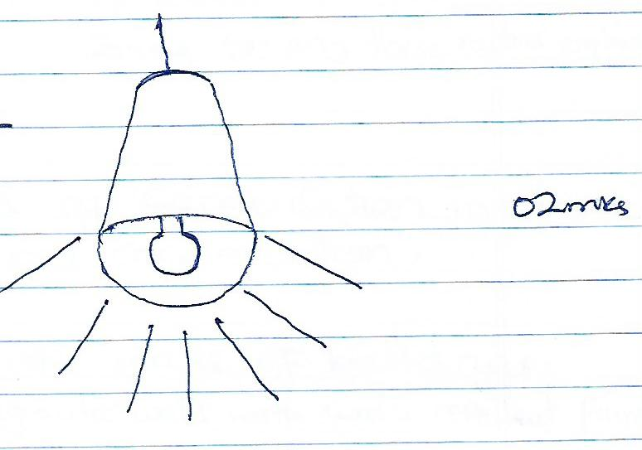

* **Indirect lighting**

The source of light is hidden and the light is thrown on to a pale wall or ceiling which reflects it back in the room.

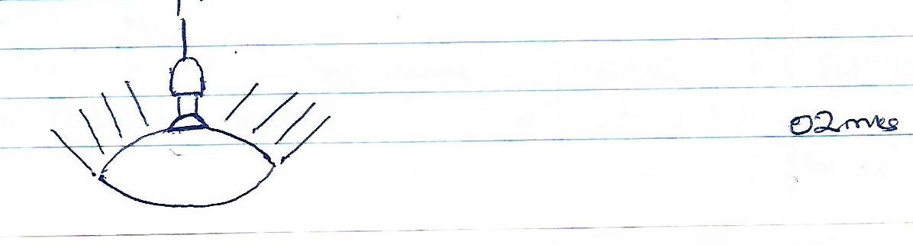

**5 a (i) Define the term evaporation .**

**E**vaporation is the escape of vapour from the surface of a liquid/ solid.

When a liquid is heated the kinetic energy of the molecules increases as a result of collision with other molecule, the molecules near the surface move towards the surface and gain energy to overcome attractive forces of the molecules behind, these escape from the surface and results in cooling of liquid if heat source is removed. 02mks

**(ii) Explain the factors that affect the rate of evaporation in laundry- drying process.**

* Surface area
* Draught effect
* Temperature
* Reduction of air pressure 06mks

2mks for any three factors explained

**(iii) What are the effects of condensation in a home? Suggest ways to avoid** condensation.

* Damp patches on outer walls of buildings to be avoided by painting outer walls with water repellant paint.
* Damp patches on walls, wooden surfaces in the kitchens, bathrooms and laundry rooms. To be avoided by good ventilation in these rooms.
* Window condensation caused by the condensation of atmospheric moisture on cold glass surfaces causing steaming.

This is overcome by double glazing or by fitting small tubular heaters along the window sill. 06mks.

**B (i) What is monochromatic colour scheme?**

This is a colour scheme involving the use of only one key colour with it’s tints and shades e.g scheme of navy blue, sky blue, royal blue. 02mks.

**(ii) How would you avoid monotony when using monochromatic colour scheme?**

* Shades, tints of that colour can be used.
* There should be variety of texture i.e smooth, rough textures used.
* Vary design
* Small objects of contrasting colours e.g toys can be used to emphasise monochromatic colour scheme and reduce monoty.
* Make use of neutral colours e.g white, grey and black.
* Choose a colour with good tints and shades 06mks.

**(iii) Discuss the effect of colours on the size of the room**

* Cool and pale colours make a room appear larger e.g blue.
* For rooms with low ceilings, use light colours for the ceilings as they create an illusion of the distance.
* Small rooms with a high ceiling – the ceiling will appear larger if painted with dark colour than the walls e.g ceiling painted with dark blue and the walls painted bright blue. 05mks.

**6 a With the aid of illustrations, explain the principle and operation of the following appliances;**

1. **Carbon dioxide fire extinguisher.**

This consists of a cylindrical tank containing sodium bicarbonate solution and near its top is a bottle of sulphuric acid (when in upright position).

When the extinguisher is inverted, the soda and acid react to produce a liquid jet that is saturated with carbon dioxide gas.

The gas displaces the oxygen and effectively smoothers the fire.

Some extinguishers as the one below contain compressed carbon dioxide, which is released when a tap punctures a seal.

Others contain bicarbonate of soda which changes to carbondioxide on the fire 4mks.

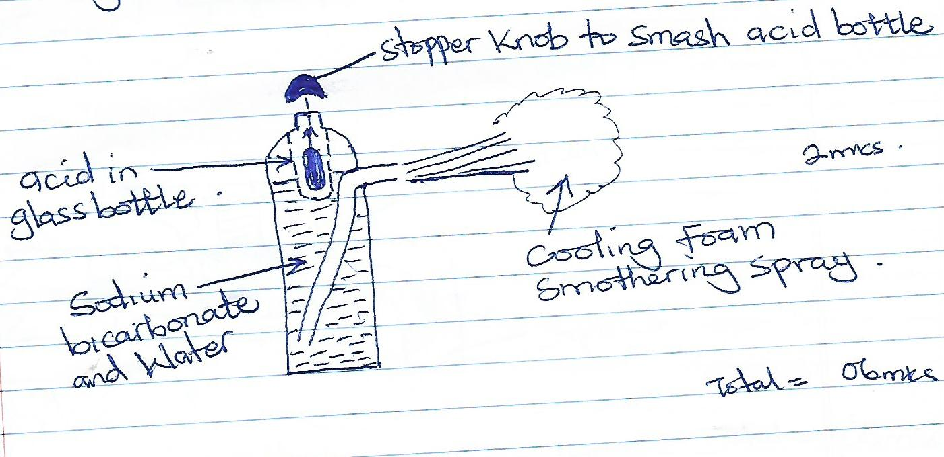

1. **Hygrometer**

This in corporates a strand of degreased human hairs when the air is humid, the hairs absorb water and increase in length.

When the air is less humid or dry, the hairs loose water and become shorter.

The movement is transmitted to the pointer through a system of pulleys and atmospheric humidity is directly indicated on the scale. 3mks

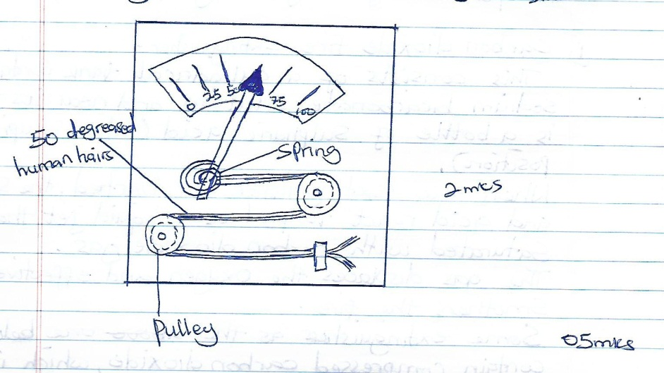

**b. Explain how a water tap is constructed to suit it’s purpose.**

- The movable part of the tap is called the jumper.

- The jumper controls the water flow and it’s supported by the water.

In cold water taps, it’s made of leather and in hot it is made / composed of fibre.

When the tap is turned around, water starts to flow out of the spout. 3 mks.

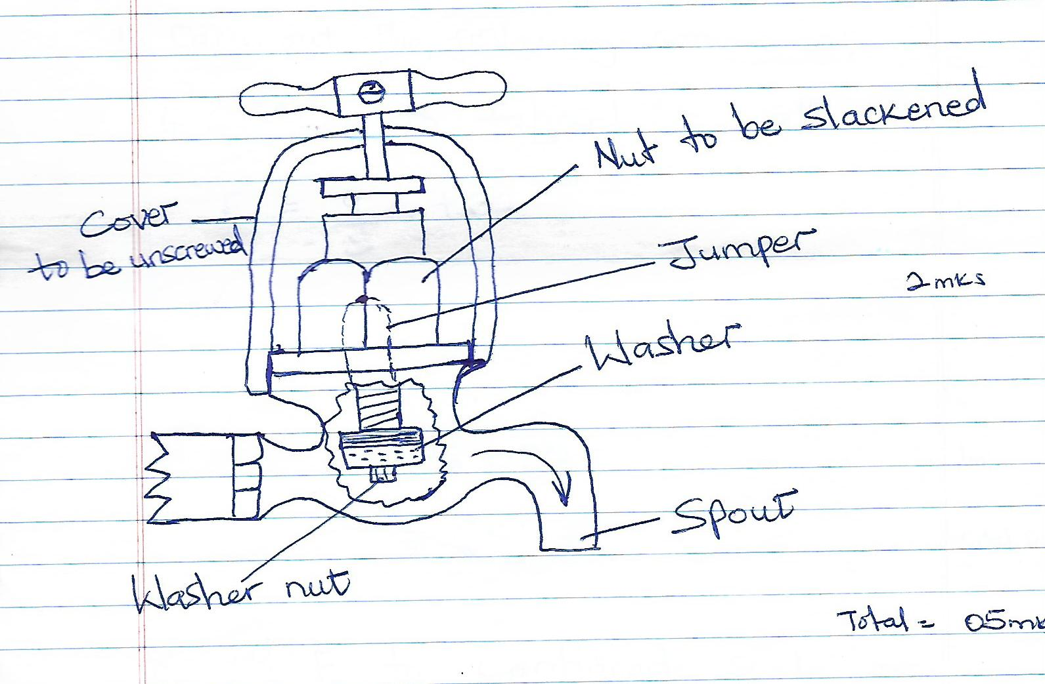

**c. Describe the scientific principle underlying construction and use of a clinical thermometer** **in a family first aid box.**

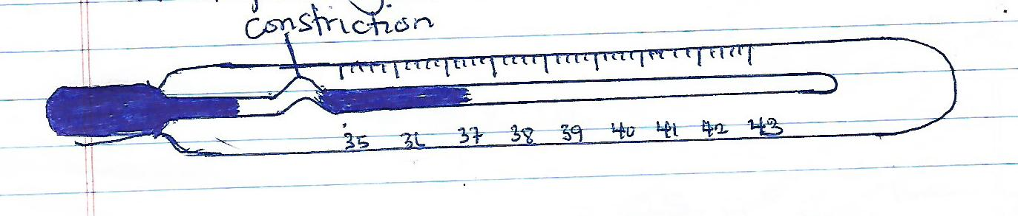

* This is a mercury thermometer designed specially to measure the temperature of the human body.
* The temperature range is normally from 350 to 450C as body temperature hardly goes above or fall below this range.
* A clinical thermometer has a constriction which keeps mercury above it before it is shaken. It gives the nurse time to read the body temperature at leisure.

05mks

1. Carry out the following conversion;
2. 200C to Fahrenheit scale

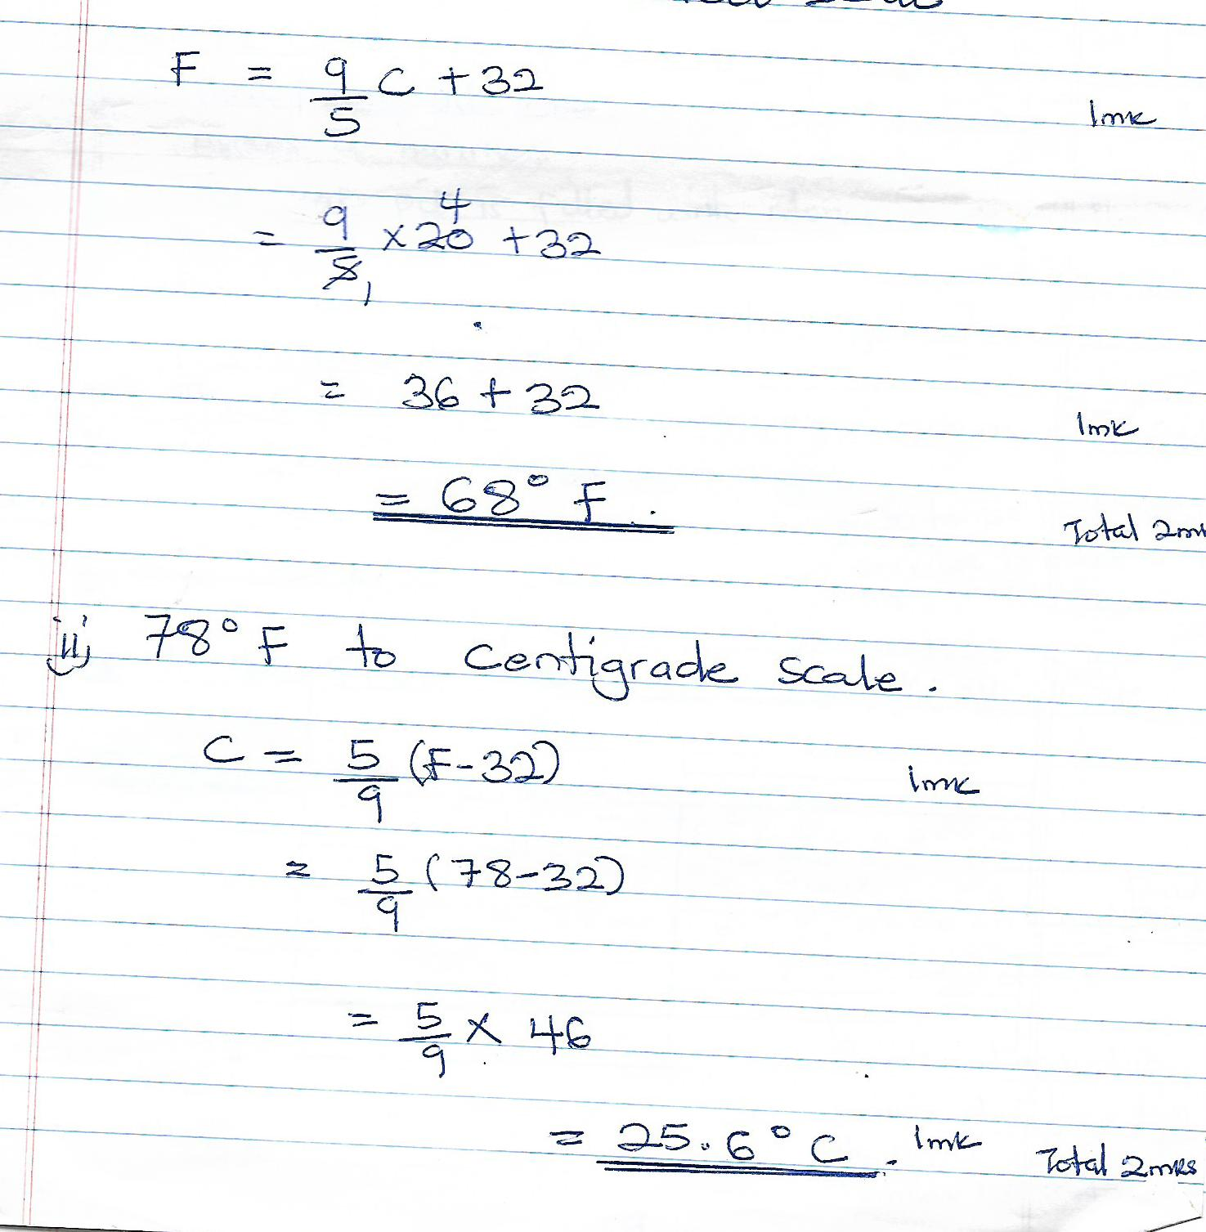

END